**VACCINE MANAGEMENT SYSTEM**

This problem statement basically explains about the vaccination process in either online or offline systems. A user who is looking to get vaccinated has two ways of getting vaccinated which are either by booking a slot for vaccination in a vaccination center or by booking a slot where the medical team gets the vaccine to the respective house. As for a slot to get vaccinated in the vaccination center the user can go to the website and login into the server by giving the user’s phone number to which an OTP will be sent to. To enter into the website the user must provide the OTP he/she received and that number will be the user's registered mobile number. After entering the website the user can also find a slot to give details about the number of doses he is gonna get and the details regarding it like the type of vaccine and remaining dates. As the user enters the website he/she must give his/her details such as name, address, city based on the details produced the website provides various vaccination centers closer to the user. The user can go through the vaccination centers provided and check if the vaccination center has the vaccine he/she is comfortable with. If the user finds the right vaccination center with the vaccine he/she is comfortable with, the user can book a slot by giving information such as Date, time and day the user wants his/her slot to be booked on. Once the details are provided a slot will be booked for the user at the given time and a message will be sent to the user’s registered mobile phone. The user must pay the asked fee for the vaccine by either any of the third party apps such as google pay, phone pay or UPI or offline. If the payment is not done by the given time the slot will be canceled. The user must go to the vaccination center by the booked slot time and get vaccinated and will be later checked for any sort of side effects. If the user chooses to get vaccinated at home he/she must get into contact with the staff of the vaccination center and book a slot by giving their details such as name, address, city. After the booking of the slot the user can pay the asked fee for the vaccine by either any of the third party apps such as google pay, phone pay or UPI or offline. If the payment is not done by the given time the slot will be canceled. Later a medical team approaches the given address by the given slot time and vaccinates the user and also checks for the side effects and leaves. If by any chance the user is not available at the booked time, the user must book for another slot and the booked slot stays cancelled.

**USE CASE1**

|  |  |
| --- | --- |
| **Use Case Name** | login |
| **Description** | In login module, the users need to give his/her mobile number to enter into the login module |
| **Primary Actor(s)** | Users |
| **Secondary Actor(s)** | System |
| **Pre-condition** | User is not logged in. |
| **Post-condition** | The user is successfully logs with the system. |
| **Trigger** | User selects the “Login” Button. |

|  |  |
| --- | --- |
| 1. | User enters the website |
| 2. | The User provides his mobile number to the system |
| 3. | The user enters the OTP sent to the given mobile Number. |
| 4. | The user is successfully logged into the website and can check into the website. |

|  |  |
| --- | --- |
| **Exception:** | The user cannot log in. |

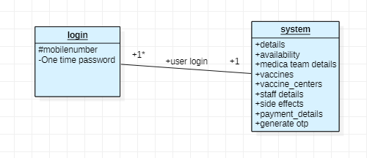

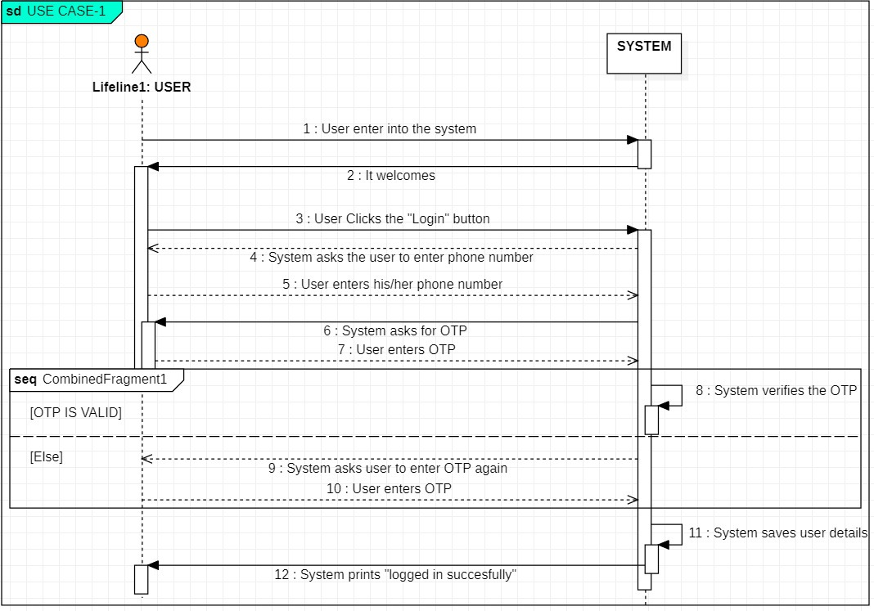

**USE CASE2**

|  |  |
| --- | --- |
| **Use Case Name** | update |
| **Description** | Admin has the privilege to make any sort of changes in the website |
| **Primary Actor(s)** | admin |
| **Secondary Actor(s)** | System |
| **Pre-condition** | admin is not logged in, the changes required to be made are not done |
| **Post-condition** | The admin is successfully logs with the system. |
| **Trigger** | When admin clicks on update button |

|  |  |
| --- | --- |
| 1. | Admin enters the website and logs in |
| 2. | Admin make the required changes. |

|  |  |
| --- | --- |
| **Exception:** | The admin cannot log in. |

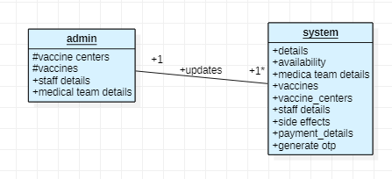

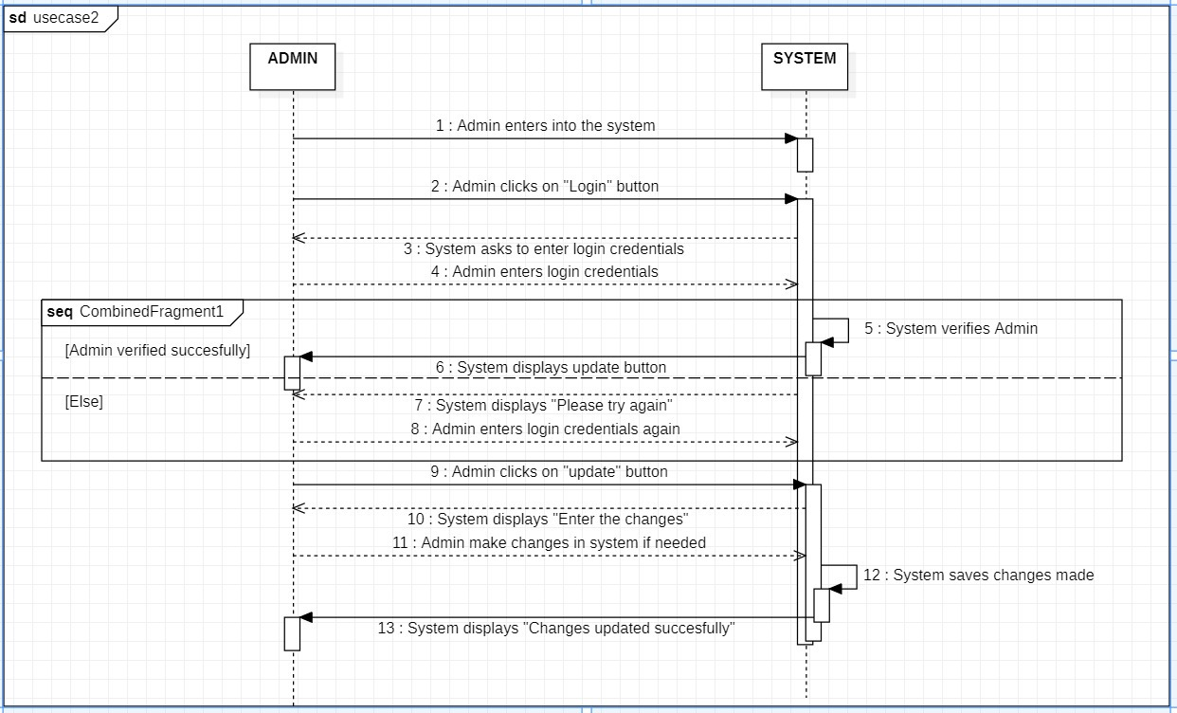

**USE CASE3**

|  |  |
| --- | --- |
| **Use Case Name** | Getting details |
| **Description** | System takes in the details of the person as per the identity(name, address, city) |
| **Primary Actor(s)** | Users |
| **Secondary Actor(s)** | System |
| **Pre-condition** | User is not logged in .He/she did not enter the wrong details. |
| **Post-condition** | The details of the person are verified |
| **Trigger** | Clicks on personal details tab |

|  |  |
| --- | --- |
| 1. | User enters the person details tab |
| 2. | User provides his details as per identity |
|  | User upload his/her identity to the system |
|  | System displays the near by vaccine centers according to their address. |

|  |  |
| --- | --- |
| **Exception:** | Details does not match with the identity ( error will be displayed) |

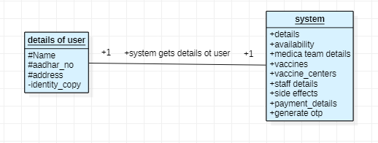

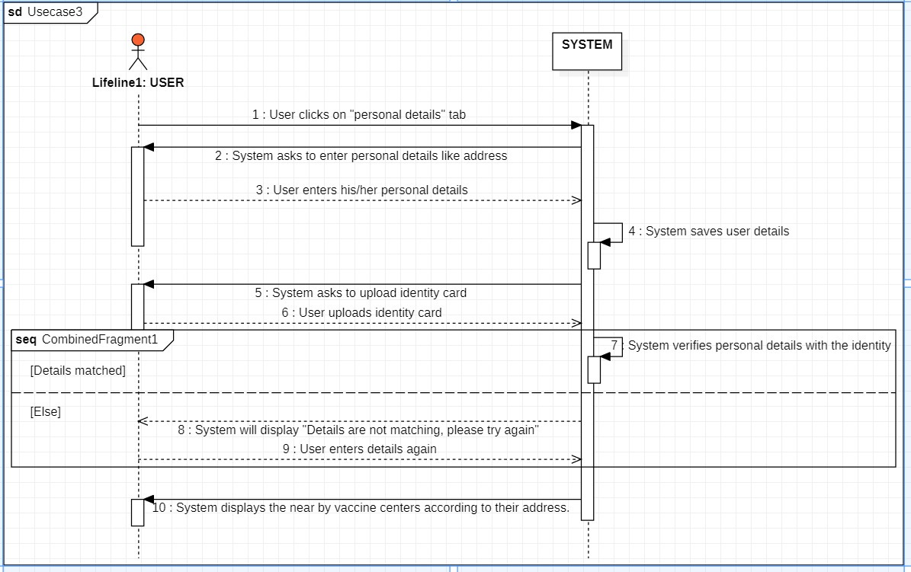

**USE CASE4**

|  |  |
| --- | --- |
| **Use Case Name** | Vaccine availability |
| **Description** | System shows availability of vaccine based on the center chosen by the user |
| **Primary Actor(s)** | Users |
| **Secondary Actor(s)** | System |
| **Pre-condition** | He/she does not know about the availability of vaccine in his/her favorable center |
| **Post-condition** | He/she gets to know the availability of vaccine in her/his favorable by center. |
| **Trigger** | User selects the vaccination center he/she is comfortable with. |

|  |  |
| --- | --- |
| 1. | As user selects the vaccine center |
| 2. | system displays the availability of vaccine at a particular center |

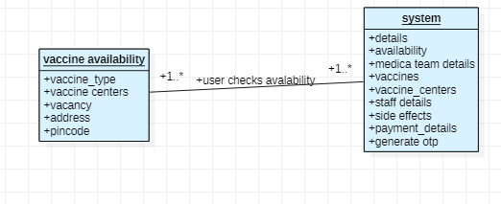

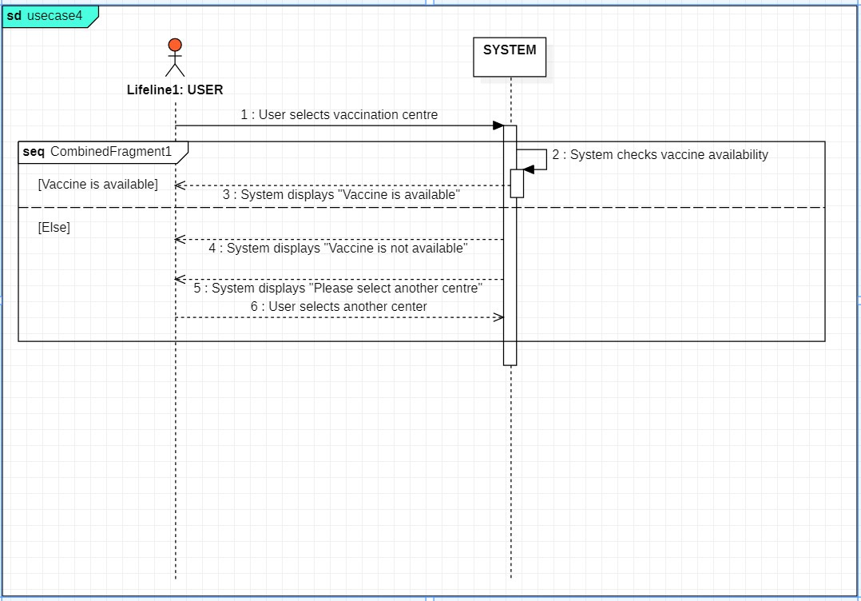

**USE CASE5**

|  |  |
| --- | --- |
| **Use Case Name** | Register |
| **Description** | user selects the vaccine he is comfortable with, and enter the details for booking the slot (date and time) |
| **Primary Actor(s)** | Users |
| **Secondary Actor(s)** | System |
| **Pre-condition** | Slot is not booked yet |
| **Post-condition** | Slot is booked and a message is sent to the registered mobile number of the user |
| **Trigger** | User books the slot |

|  |  |
| --- | --- |
| 1. | User enter the vaccine availability tab |
| 2. | User selects the vaccine he/she needed |
|  | He/she enter the details required for the booking of the slot |
|  | Slot is success fully booked |

|  |  |
| --- | --- |
| **Exception:** | Error displayed ‘slot is FILLED ’ if slot is completely filled  If vaccine that user selected is not available error is displayed and user checks for other vaccine/vaccination center |

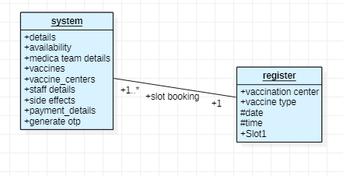

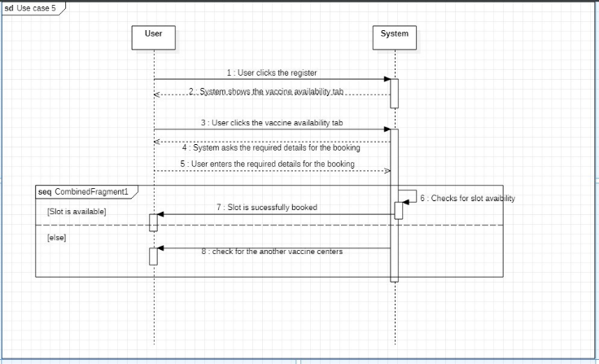

**USE CASE6**

|  |  |
| --- | --- |
| **Use Case Name** | payment |
| **Description** | User pays for the vaccine based on the type of vaccine |
| **Primary Actor(s)** | Users |
| **Secondary Actor(s)** | System ,staff |
| **Pre-condition** | User did not made any payment regarding vaccination |
| **Post-condition** | Payment is done for the required vaccine |
| **Trigger** | User pays for the vaccine |
| 1. | After registering the vaccine/slot bill will be provided to the user |
| 2. | User pays the bill using 3rd party app(phonepe, google pe) |
|  | Payment is successfully received |

|  |  |
| --- | --- |
| **Exception:** | If payment failed ,booked slot is cancelled and a message is sent to registered mobile |
| **Alternatives** | If online payment is not available it can be done at vaccination center |

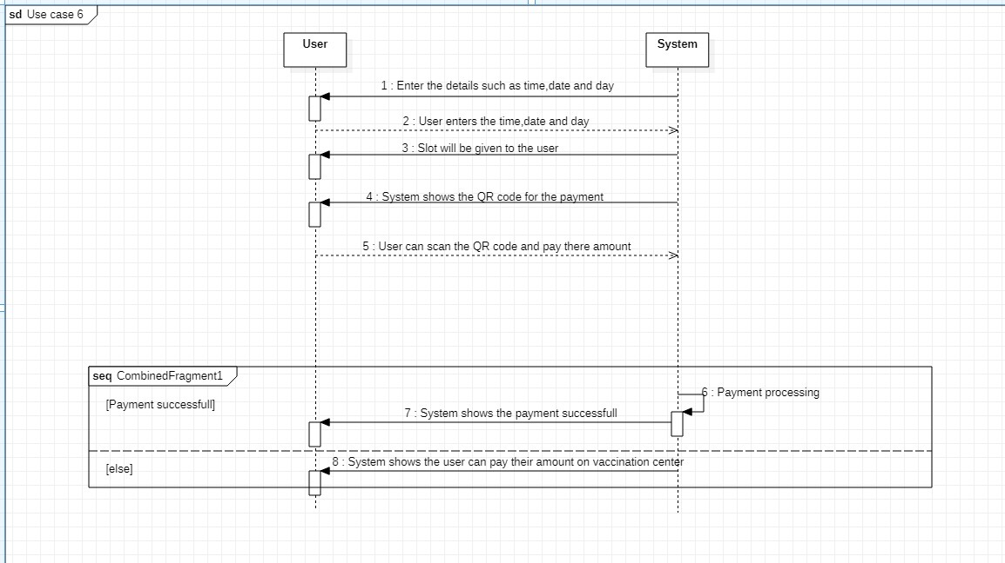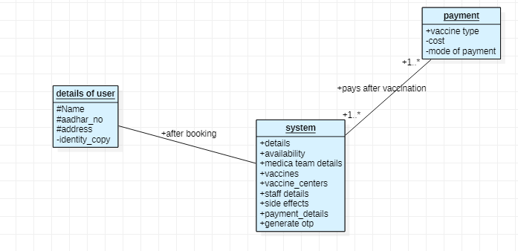

**USE CASE7**

|  |  |
| --- | --- |
| **Use Case Name** | Offline vaccination |
| **Description** | User selects the slot that he/her is comfortable with, medical team contacts the user personally where user get vaccinated at home |
| **Primary Actor(s)** | Users, |
| **Secondary Actor(s)** | Medical team, staff |
| **Pre-condition** | User does not get into contact with the staff and slot is not booked |
| **Post-condition** | User gets into contact with the staff and slot is booked |
| **Trigger** | User books the slot for offline vaccination |

|  |  |
| --- | --- |
| 1. | User contacts the staff of the vaccination center |
| 2. | User provides the required details like name, id, address |
|  | Staff checks for the vacancy of the slot and books the slot |
|  | Medical team contacts the user at the given slot and vaccination is done |

|  |  |
| --- | --- |
| **Exception:** | Requested slot by the user is not available and user goes for another slot  Vaccine requested by the user is not available  If the is not available is not available at booked time ,User need to re-book the slot |

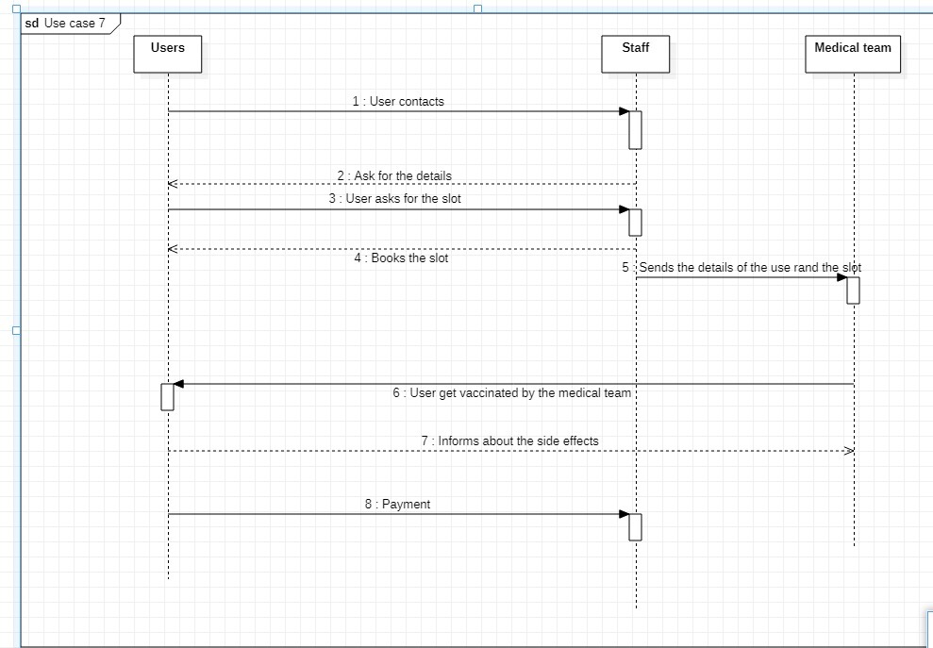

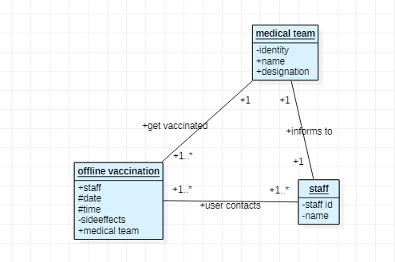

**USE CASE8**

|  |  |
| --- | --- |
| **Use Case Name** | Side effects |
| **Description** | After vaccination, if person goes through any side effects. He/she contacts the staff. Medical team approaches the person |
| **Primary Actor(s)** | Users, |
| **Secondary Actor(s)** | Medical team, staff |
| **Pre-condition** | User gets vaccinated |
| **Post-condition** | Medical team approaches after person goes through the side effects |
| **Trigger** | User feels the side effects |

|  |  |
| --- | --- |
| 1. | Person gets vaccinated |
| 2. | Medical team asks the person to wait 10-20 min |
| 3 | User goes through the side effects and inform the same to staff |
| 4 | Staff contacts the medical team for the support |

|  |  |
| --- | --- |
| **Exception:** | User does not feel any side effects |

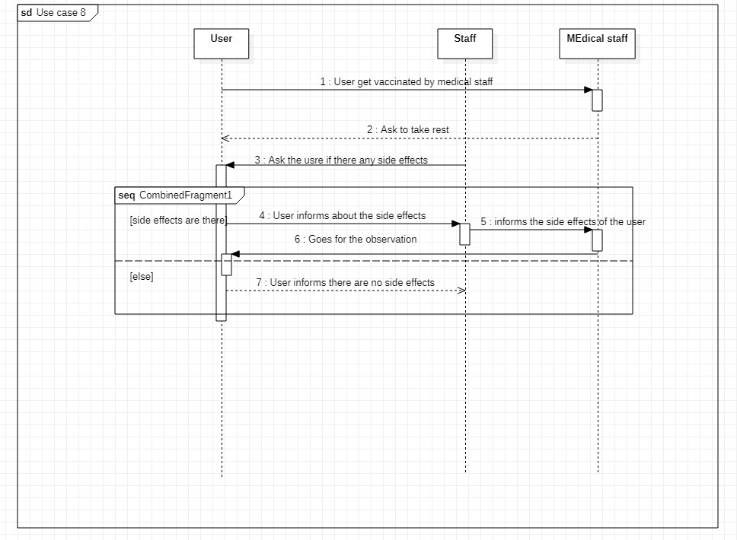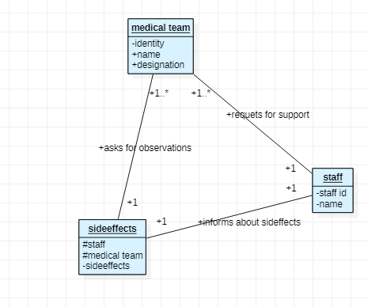

**CLASS DIAGRAM**

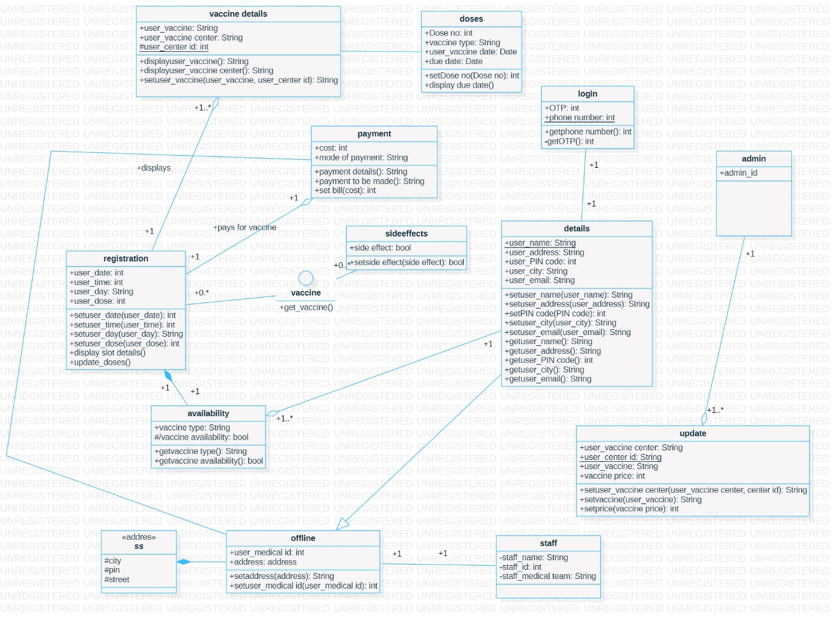

Get_vaccine is INTERFACE

Availability -> registration COMPOSITION

Adresss ENCAPCULATION

|  |  |  |
| --- | --- | --- |
| CB.EN.U4CSE20213 | Chintapalli Jithendra Durga Kumar | Use case (login, update, getting details,vaccination availability) |
| CB.EN.U4CSE20207 | Anne Sai Sumanth Chand | Use case problem statement, object diagrams |
| CB.EN.U4CSE20219 | GAJULA SUJAN SAGAR | Usecase (registration ,payment, offline, sideeffects ) |
| CB.EN.U4CSE20206 | AMIDELA ANIL KUMAR | class diagram and properties |
| **WHOLE PROJECT IS DONE BY ASSITING EACHOTHER THROUGH TEAMS MEET** | | |